SuperAdmin Test Comment

1. 

* Change icon
* Change name to: CDS Super Admin

1. 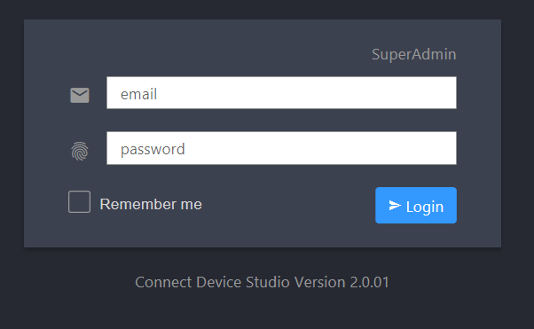

* Wording: Super Admin
* Wording: Connected
* Bug: There is no any message when I input wrong ID/PW.

1. 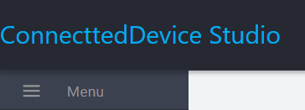

* Wording: Connected Device Studio

1. 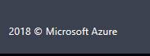

* Font size too small, can align with other?

Super Admin Pages

1.  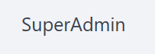 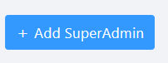

* Wording: Super Admin

1. 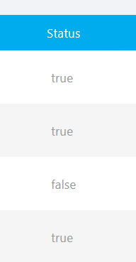

* Change Status to Active
* Change true to: green ball icon
* Change false to: red ball icon

1. 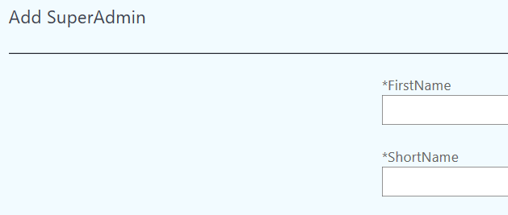

* Wording: First Name
* Wording: Last Name

1. 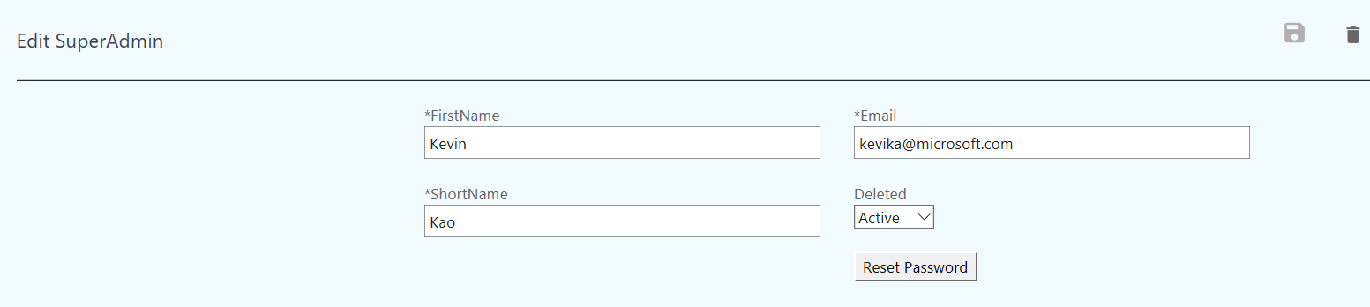

* Wording: Edit Super Admin
* Wording: First Name, Last Name
* Move “Reset Password” to upper.
* Change “Deleted [Pull Down Menu]” to “Status: [Radio Option]: Active/Inactive ”
* Bug: when I change “Deleted [value]”, and save it, the Table UI still show old Status value.
* Call Andy to change Super Admin Delete API, we need to real delete it from DB. (Currently, Delete API update delete flag to true).

1. 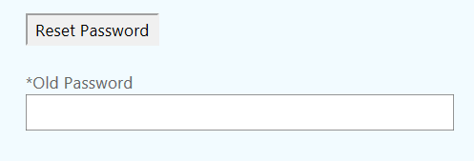

* Remove Old Password. We don’t need it on Super Admin.

Device Class Page

1. 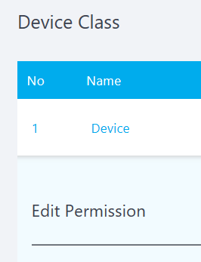 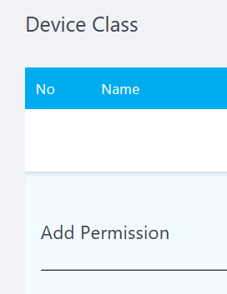

* Wording: Edit Device Class
* Wording: Add Device Class

Subscription Plan

1. Show below field on Table

No, Name, DefaultPlanDays(Duration), DefaultMaxMessageQuotaPerDay(Msg Quota/day), DefaultStoreHotMessage(Hot Message), DefaultStoreColdMessage(Cold Message).

1. 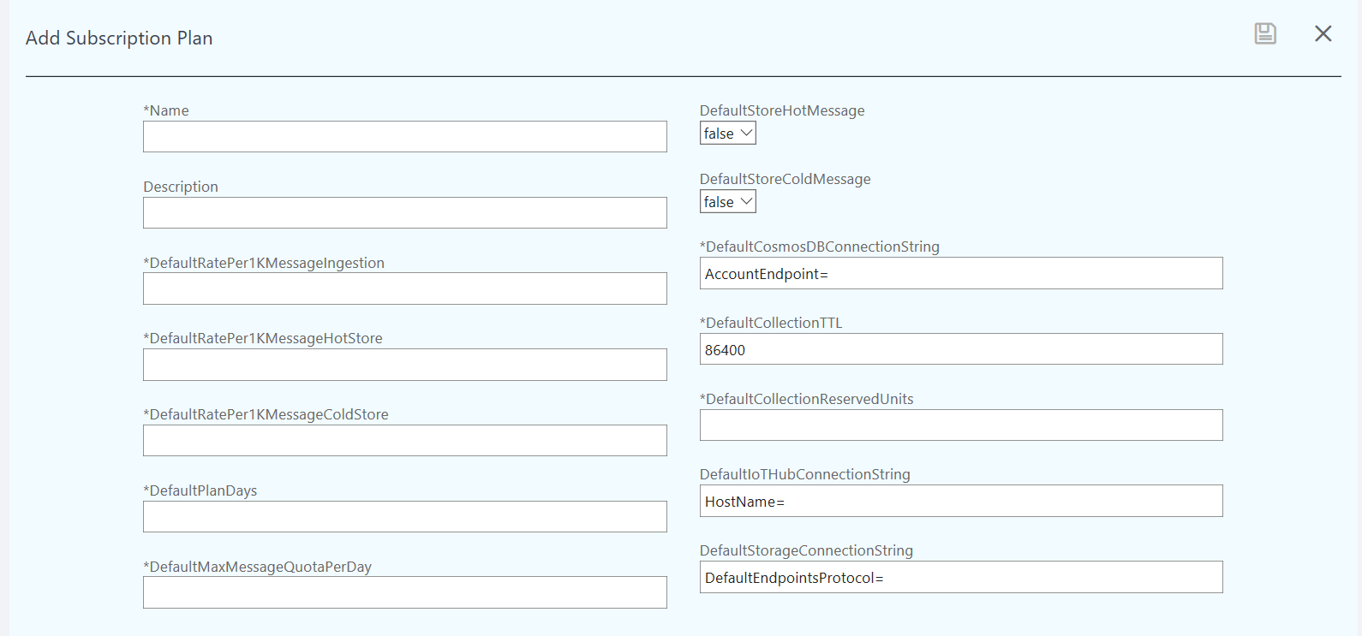

* Wording: Pus ‘space’ on each long name. For example: Default Rate Per 1K Message Ingestion
* Change Pull down menu to Radio button. (Default Store Hot Message, Default Store Cold Message)

Client Page - Detail

1. 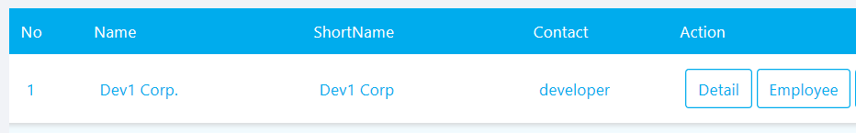

Field: No, Name, Contact, Allow Domain

1. 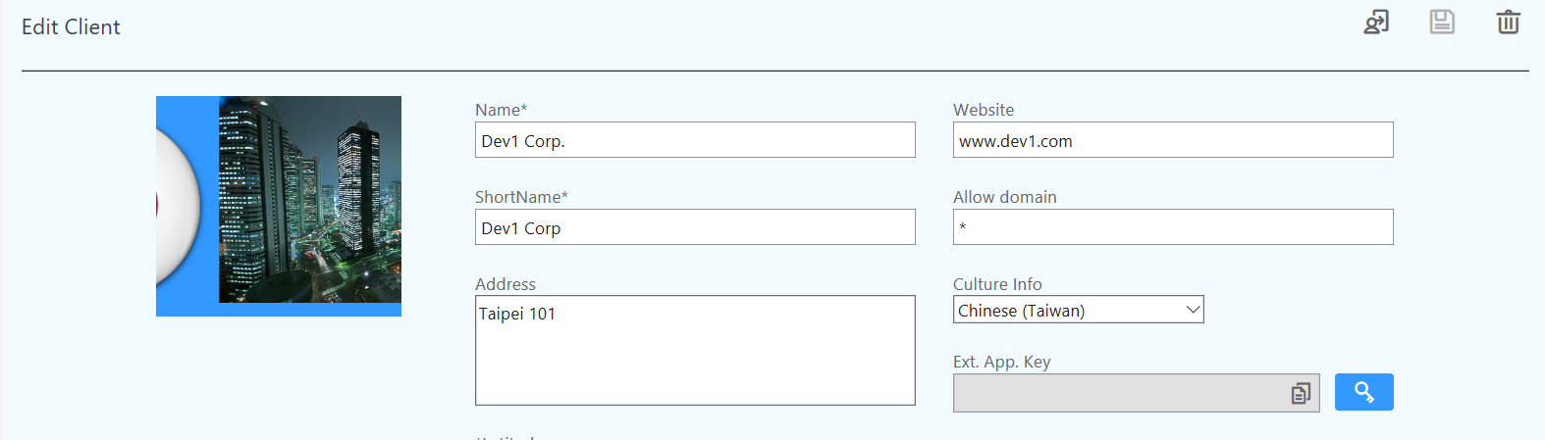

* Image be cut.
* Wording: Short Name
* Wording: Ext. App. Key => App Authentication Key

1. D
2. D
3. D
4. D
5. D
6. d